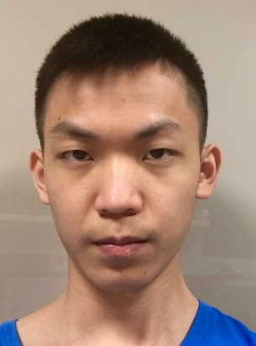

* (2015-2016): Undergraduate 1st and 2nd Year of BSc Computer Science at The University of Sheffield
* (2014-2015): Sheffield International College (SIC)
* (2012-2014): Guigang Senior High School in Guangxi, China

Education

Birthday: 2nd March 1997

Sex: Male

Nationality: Chinese

Marital Status: Unmarried

Personal Detail

Phone Number:07340241601

Personal Email Address: [1099404025@qq.com](mailto:1099404025@qq.com)

University Email Address: [jchen54@sheffield.ac.uk](mailto:jchen54@sheffield.ac.uk)

Current Address:

Studio 528, Vita Student, Telephone House, 40 Charter Square, Sheffield

S11BA

Junjin Chen

**Description about my study**

**English**: My English is good. I am able to talk to a native English normally. I know a lot of vocabulary in the field of computer science.

**Math**: In my senior high school, I got some general idea about the world. I am especially good at math, for which I have been keeping a good grade since I was in my primary school. In the Computer Science department, I study a lot about the logic, now I am very confident in this field.

**Programming languages**: Although I had no idea about java until I went to the university, in the 1st year, I practiced a lot of java, had done a lot of assignments, for example, coding a robot and making it follow a certain path to the destination, making an app that deal with the data of weather read from a website and display it using the GUI. Now I can do Inheritance and Polymorphism of java class, jUnit testing, IOException, multithreading and etc.

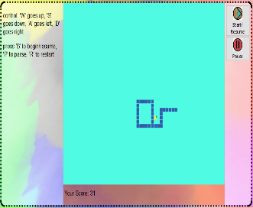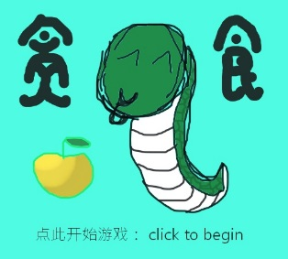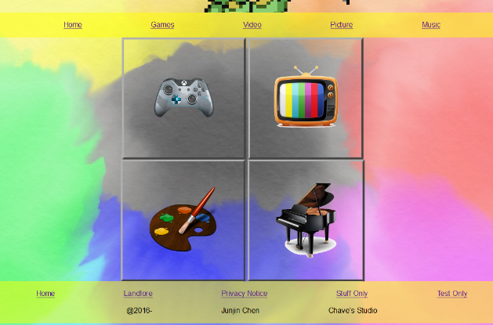

Achievement

* Social Innovation Lab
  + Creativity, Management Skill, Teamwork Ability, Speech Ability.
* Examination condition filming volunteer
  + Performance Ability
* 24 hours inspiration volunteer (Selling tickets of Lectures)
  + Sales Skill
* 30 hours gameJam (make a game with given theme in 30 hours)
  + Time-Management Ability
* Being a Mentor of 2 Mentees
  + Guiding Ability
* Coding competition
  + Pair Programming Skill
* Photoshop Lessons

I also learned other languages such as Ruby, C++, PHP (and Html, CSS, JavaScript). I wrote a Sokoban game in Ruby. And my classmates and I as a group, made a website for a restaurant which had a food-information managing system and a user system. It enabled the user to ordering foods by sending tweets. I am also writing a website on my own, using the PHP. There are already some games on it such as Snake Game. I am planning to make more games and share them with other people.

**AI** (artificial intelligence): Been through my 1st year, I learned that there are many different agents to perform different tasks. One basic thing I learned of AI is that machine deciding is just searching. I am now learning Haskell, which is a functional Programming Language. It is believed to be a better language to perform AI than Java. I also studying the data driven computing, which tells us how to analyse a bunch of data and get the probability of future events, and it is another basic thing for machine learning.

**Software Engineering**: This module teaches me how to manage a software manufacturing process, which method to be used to manage different software developing process, what problems are we facing when making a software, how to work with teammates and etc. As a group, my classmates and I implemented the agile method and made that restaurant website I mentioned.